**DC power (Pinst = Vdc*Idc) instantaneous:**

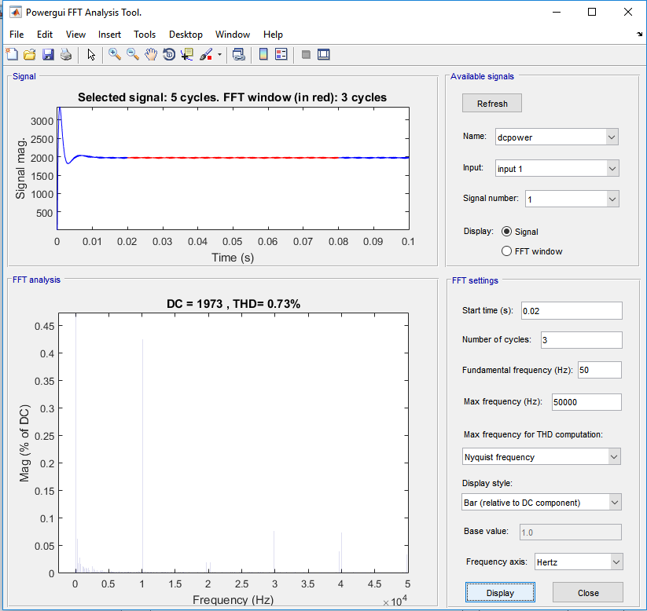

**AC power (Pinst = Vab*Ia + Vcb*Ic):**

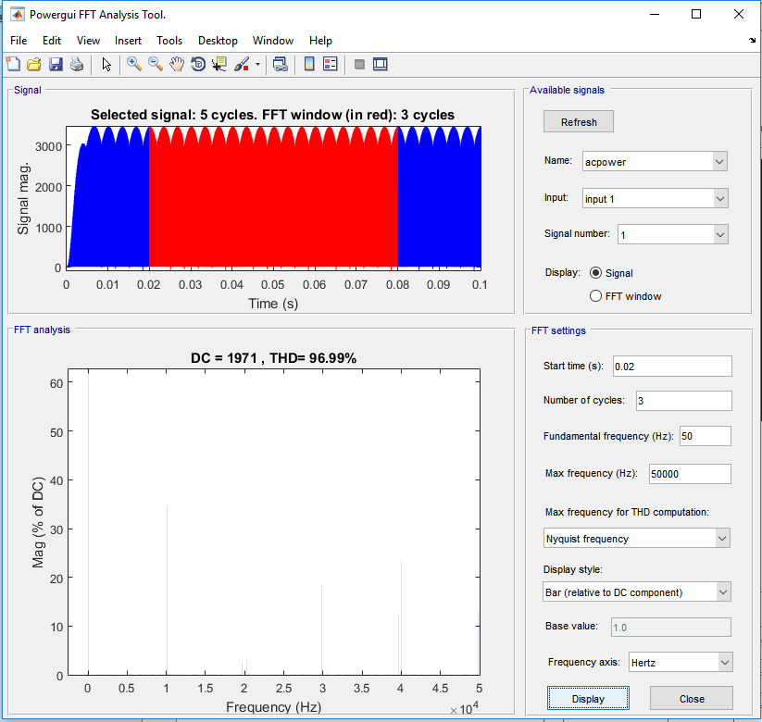

**Efficiency (100 * Pac_inst / Pdc_inst):**

